RWInc Phonics
It is our main aim at Front Street Primary School to ensure all children can read fluently and to achieve this as quickly as possible. To do this effectively, staff deliver a structured synthetic phonics programme.
Children in Reception, Year 1 and Year 2 use a synthetic phonics approach to learn to read. Some children in Key Stage 2 may also still be a part of the programme.
What is Phonics?
Phonics is a way of teaching children to read quickly and with skill. Children are taught how to:
- recognise the sounds that each individual letter makes;
- identify the sounds that different combinations of letters make - such as 'sh' or 'oo'; and
- blend these sounds together from left to right to make a word.
Children can then use this knowledge to 'de-code' new words that they hear or see. This is the first important step in learning to read.
Why Phonics?
Research shows that when phonics is taught in a structured way – starting with the easiest sounds and progressing through to the most complex – it is the most effective way of teaching young children to read. It is particularly helpful for children aged 5 to 7.
Almost all children who receive good teaching of phonics will learn the skills they need to tackle new words. They can then go on to read any kind of text fluently and confidently, and to read for enjoyment.
At Front Street we use The Read Write Inc. Phonic resources and follow a rigorous teaching structure, allowing us to meet the needs of the children. Our approach enables every child to become a confident and fluent reader at the first attempt.
The children:
Learn 44 sounds and the corresponding letters/letter groups using simple picture prompts:
- learn to read words using sound blending
- read lively stories featuring words they have learned to sound out
- after meaningful discussion led by an adult, children show that they comprehend the stories by answering questions.
Children who need extra support to maintain progress, will participate in additional intervention to ensure that they do not fall behind their peers.
Learning Set 1 Speed Sounds
These are the Set 1 Speed Sounds written with one letter:
m a s d t i n p g o c k u b f e l h r j v y w z x
These are the sounds written with two letters (children call these ‘special friends’)
sh th ch qu ng ck
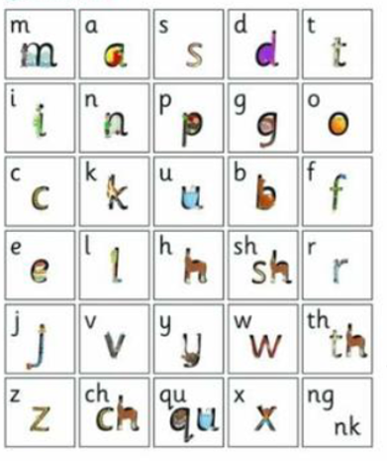
Learning Set 2 Speed Sounds
These are the Set 2 Speed sounds:
ay ee igh ow (blow the snow) oo ( as in zoo)
oo (look at the book) ar or air ir ou (shout it out) oy
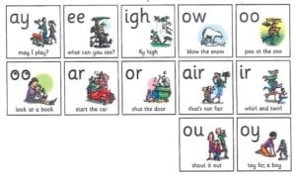
Learning Set 3 Speed Sounds
ea (tea) oi (spoil) a-e (cake) i-e (smile) o-e ( home) u-e (huge) aw (dawn)
are (care) ur ( nurse) er (letter) ow (brown) ai (snail) oa (goat) ew (stew)
ire (fire) ear (hear) ure (sure)
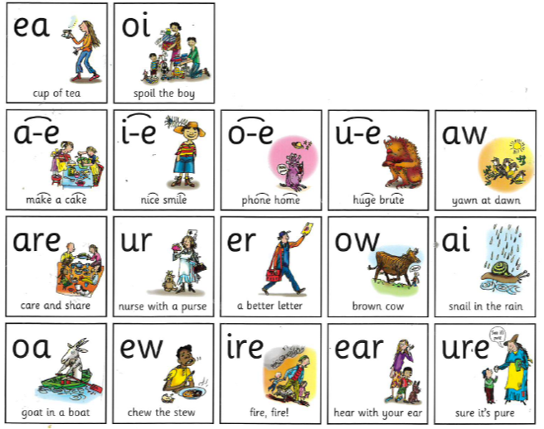

Oxford Owl Parent Guide to RWInc
If you would like to help teach your child, practise saying the sounds. You can find out how to say the sounds on the free parent support website.
Parent Guide to Phonics

