Dear Parent/Carer 17 June 2022

At last the sun is shining. Let’s hope we manage to get some deck chairs out this weekend and have a BBQ.
The children have been using the gazebo for story time and snack time in Nursery this week. What a lovely place to be able to enjoy a story in the shade.
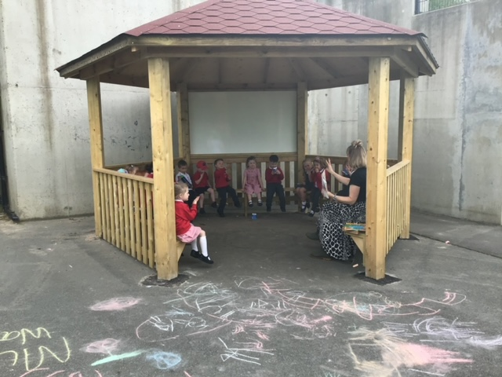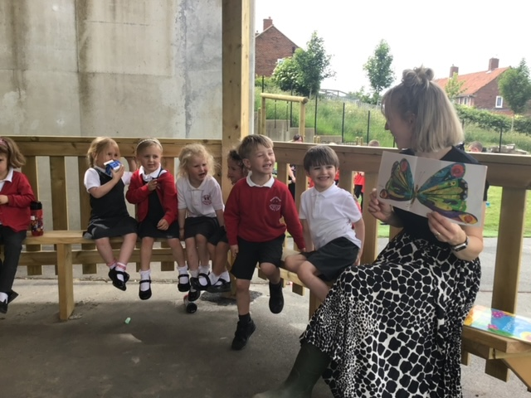

Gateshead School Dance Festival
WOW, WOW, WOW! After weeks of rehearsals, we all had a fantastic night at the Gateshead Dance Festival on Wednesday. Front Street had 75 mini Tina Turner dancers who performed their dance to a melody of Tina songs! The comments from the audience were amazing and we were all very proud of each of our dancers. Please use the following link to see the recording on our school YouTube page. https://www.youtube.com/watch?v=GVXuln9jxyA

Thank you to Miss Gilderoy and Miss Routledge for doing lots of organising from behind the scenes.

MASSIVE THANKS to Lee who came and put the routine together and persevered through lots of rehearsals. Many moons ago Lee was in one of my Dance Festival dances. He was my Michael Jackson in Thriller and here we are years later and he is now leading the Dance Festival dance. You never know this might be your child in the future. Home (lbpaa.co.uk)
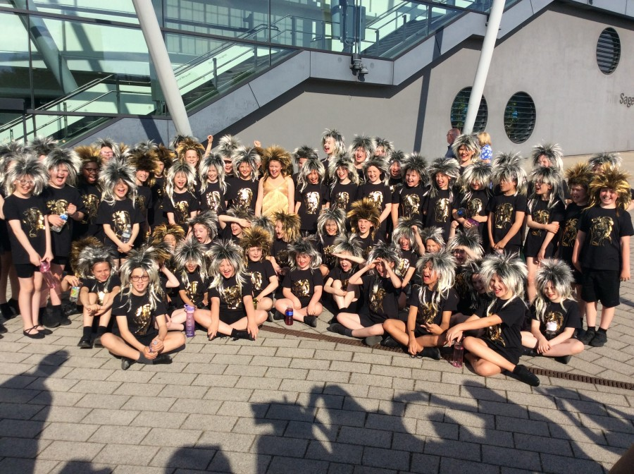

Sports Day Reminder
Our Sports Activity Day will be on Monday 20th June, this is for children only.
Children are to come to school in their PE kits and remain in them all day.

School lunches will only have one option – meat-free pizza and Curly fries.
Thank you for your continued support. #TEAMFRONTSTREET. Next year we are hoping to plan something even bigger so the whole school community can be involved (start practising now 😊).

New Parent Meetings
New Nursery Parents Wednesday 22nd June 2:30pm
New Reception Parents Wednesday 22nd June 5pm

Next Academic Year
After lockdown and the pandemic, children have returned to school and coped well with their academic work. You should be really proud of them. The challenge has been learning to socialise in large groups, regulate emotions and learn how not to win or be the winner in games. Emotional resilience is something lots of schools are talking about after lockdown.
Historically, children are in a class and never really mix with the other partner class (this is a real shame). We are in a luxurious position that we have 2 classes per year group. Because of this we have the ability to develop children’s social skills, promote citizenship, and build confidence across a larger number of children. Next year, to help with emotional resilience, children will be placed in a register class, but the whole year group will mix for various lessons across a week.
This WILL NOT be based on academic ability. Mixing the children will help them to socialise with different children. This is a skill that children will need as they progress through their school years. Children may then find new friends in the other class that they have never really mixed with before and you never know may blossom into great friends. Children will then have the opportunity to be taught by different teachers in different classrooms within the year group.

Year 6 already do this across 3 teaching staff and this is good preparation for secondary school.
Year 1 will very much work between 2 classrooms and 2 teachers as continuous provision will be the main part of their curriculum in the autumn term.

https://earlyexcellence.com/latest-news/press-articles/maximising-learning-in-key-stage-one/
This is seen as a great start to help children settle into Year 1 and is a bridge between Early Years and Key Stage 1.

As transition is fast approaching, classes will be shared with you and children next week for the summer term transition days.
In September remember this will be a base, a contact, but not necessarily all day, every day for the year.

Mud Kitchen
We are thrilled our new mud kitchen has arrived for Early Years to enjoy. It is amazing!
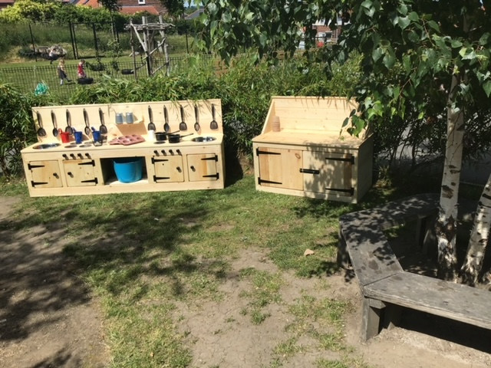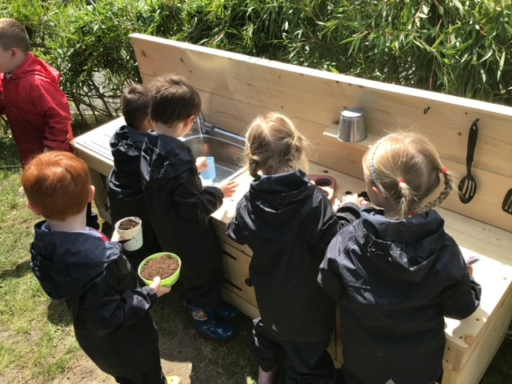

Key Stage Two Online Usage Survey
The digital leaders would like to say a big thank you to everyone who completed the survey we set up before the Easter holidays. Year 6 have been busy with SATs so it has taken longer than expected to review the data. Now it is complete, they have uncovered some interesting results and wanted to share some with you all…
- They were pleased to find that 75% of our KS2 pupils are only online for a limited amount each day and that most of these children also play with their friends online.
- They also noted that approximately half of the pupils asked use games and social media platforms above their age rating such as TikTok (13+), Whatsapp (16+) and Fortnite (13+).
In school, we talk a lot about how to stay safe online, however, it is a team effort so all of our parents/carers can help their children to stay safe too.
Here are some reminders about how to keep your children safe online at home…
- It is important to have regular conversations about staying safe online and to encourage children to speak to you if they come across something worrying online.
- Talk to your child about the importance of creating a safe online environment, including keeping any log-in details and passwords safe.

Just to remind you this is a Safeguarding school and we have a duty to pass on any concerns to Children’s Services. Our designated Safeguarding Leads are – Mrs Gladstone, Mr Kelly, Miss Hoult, Mrs O’Neill, Mrs Marshall, Mrs Wilkinson and Miss Casey. If you have any concerns, please do not hesitate to get in touch and we can have a chat and hopefully we can help.

H J Gladstone
Headteacher

