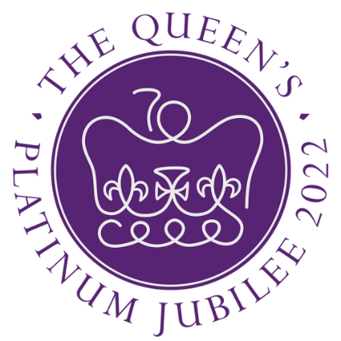
Dear Parent/Carer 27 May 2022

The children have looked bright & colourful in red, white & blue today. There are some amazing outfits and accessories. Thank you for your support in helping with this. The children have had a special Jubilee lunch and have sung, danced, and partied amongst the bunting. They have also received a special keepsake which they should have brought home.

We break up for half term today and I hope you all manage to have some Jubilee parties next week!

Thank you to Gillian and her team for another SPECTACULAR special lunch! (See the website for all photos)
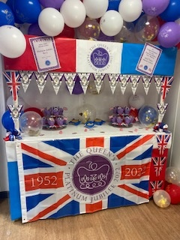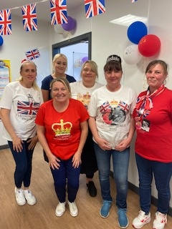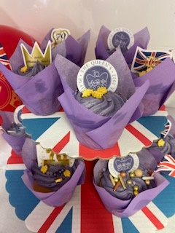

Jubilee Art Competition
A big well done to everyone who entered the school art competition. So much time and effort was put into the work that was entered. As always, staff and visitors to the school have been blown away by the talent and level of skill on display. The whole school have had the chance to vote and the Arts Ambassadors counted them all up to see who had won. (Well done to the Arts Ambassadors as this was a HUGE task!) The winners are Layla K and Nahla . Runners up are Anya, Mila and Archie C. Fantastic work everyone, I am sure Her Majesty would be proud!

Well Done
Congratulations to Hattie & Lola who represented Front Street at the Tyne & Wear Gymnastics finals!
Well Done to years 5 & 6 who participated in the Gateshead Fun Run at Saltwell Park.

Swimming
A reminder that Year 5 have now ended their swimming lessons. After half term, Year 6 will attend lessons every Tuesday afternoon. It is a government requirement that all children should be able to swim 25 metres – unaided, by the end of Year 6. All children will attend lessons at the pool at first, to assess those who can meet the stated requirement.

Reading Plus
Well done to our Year 6 children who have attended school every day from 8.30am for Reading Plus!
We now think that they deserve an extra 20 minutes of a lie in, so they no longer need to come into school for the session. Reading Plus will now happen for Year 6 during the school day. Thank you.
Year 5 will be invited to start coming to Reading Plus after half term – watch out for details.

eSafety
New app: ‘Discord’. As we head into the half term holidays, we like to remind children (and parents and carers) of online risks, group chats etc. This guide explains the new app Discord. Please continue to be vigilant and to help our pupils stay safe.

NSPCC
This week in school we have hosted NSPCC ‘Speak Out, Stay Safe!’ assemblies. The children have been learning about the types of abuse, the number for Childline 08001111 and who they can share their worries with both at home and at school. Year 6 will have workshops on 8th June to explore the 'Speak Out, Stay Safe!' campaign in more detail.

Reminders
Please ensure all Music fees & Nursery fees for the summer term are paid by Monday 30th May.
SCHOOL IS CLOSED TO CHILDREN MONDAY 6TH JUNE.

HAPPY PLATINUM JUBILEE

