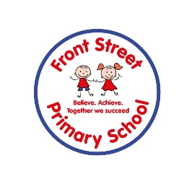
MFL Phonics Plan

Phonics is taught on a 2 year cycle to ensure repetition and greater understanding. Two sounds are taught each half term in Key Stage 2. We use Les Planetes Phonique powerpoints plus additional classroom activities.

Year 3 and 5 Year 4 and 6
oi h
in ouill

on/om qu
ch o (au,eau)

ou i/y
u ei

r j
eu an

ai/e un
i th

ui silent letters 1
a silent letters 2

