4O’N’s Shout Outs
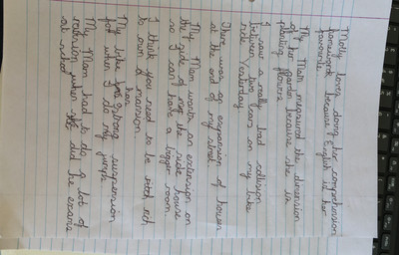
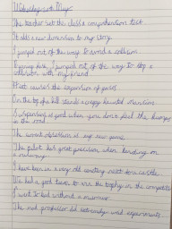
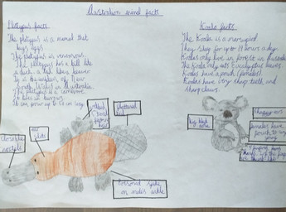
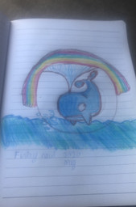

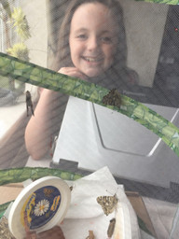
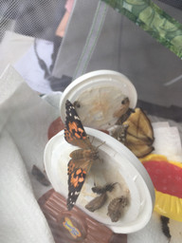
Thank you for working hard this half term. Enjoy your week off.
Finlay took part in the World’s Largest Online Art Lesson and he did very well.

Joel used his spellings in some super sentences.
Ryan researched and drew animals from Australia.
Beautiful butterflies hatched this week.

