4O’N’s Shout Outs
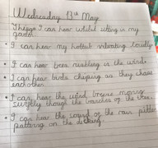
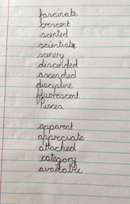
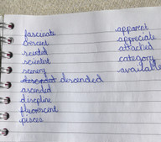
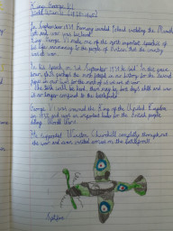
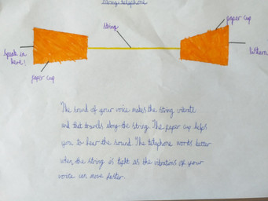
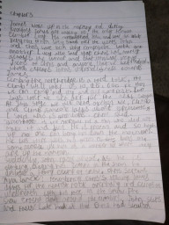
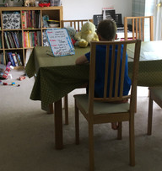
Thank you for trying hard again this week. You make me very proud. You are 
Story writing galore – Ducky’s Great Escape and an epic Mountain adventure by James.
Regular SPaG.com users this week are:

Finlay S, Elizabeth,
Amelia, Finlay W, Joel, Ryan, Ruby, Ava L, John, Josh and Freya I.

Super Spelling and handwriting work from Ava, Joel and Oliver.
A string telephone made by Ryan and his super drawing of a Spitfire and research.

